**ABSTRACT**

**Microcontroller/Microprocessor** is the most versatile device in the world. It’s once a creature of science fiction is today a reality. In real sense it is a device which allows human beings to implement their intelligence in machines. Visitor counting is simply a measurement of the visitor traffic entering and exiting offices, malls, sports venues, etc. Counting the visitors helps to maximize the efficiency and effectiveness of employees, floor area and sales potential of an organization. Visitor counting is not limited to the entry/exit point of a company but has a wide range of applications that provide information to management on the volume and flow of people throughout a location. A primary method for counting the visitors involves hiring human auditors to stand and manually tally the number of visitors who pass by a certain location. But human-based data collection comes at great expense. Here is a low-cost microcontroller based visitor counter that can be used to know the number of persons at a place. All the components required are readily available in the market and the circuit is easy to build. The final result of this project is a thorough design for an autonomous visitor counter including a detailed test plan for the use by subsequent design teams.

**Contents**

**Topics Page No.**

|  |  |
| --- | --- |
| 1. INTRODUCTION | 3 |
| 1. PROBLEM ANALYSIS | 4 |
| 1. REVIEW OF LITERATURE    1. SENSORS    2. LOGIC CONTROL CIRCUIT    3. MICROCONTROLLER    4. DISPLAY | 5  6  8  11 |
| 1. IMPLEMENTATION DETAILS    1. SCHEMATIC DIAGRAM    2. CIRCUIT OPERATION | 13  14 |
| 1. ALGORITHM | 15 |
| 1. OUTPUT | 16 |
| 1. APPLICATIONS | 17 |
| 1. CONCLUSION   10.BIBLIOGRAPHY | 18  19 |

1. **Introduction**

This project titled **“Microcontroller based Bidirectional Visitor counter”** is designed and presented in order to count the visitors of an auditorium, hall, offices, malls sports venue, etc. The system counts both the entering and exiting visitor of the auditorium or hall or other place, where it is placed. Depending upon the interrupt from the sensors, the system identifies the entry and exit of the visitor. On the successful implementation of the system, it displays the number of visitor present in the auditorium or hall. This system can beeconomically implemented in all the places where the visitors have to be counted andcontrolled. Since counting the visitors helps to maximize the efficiency and effectiveness of employees, floor area and sales potential of an organization, etc.

**2. Problem Analysis**

Design of a bidirectional visitor counter using microcontroller. The design is analyzed by understanding the working principle of the circuit which is shown in the form of a block diagram as follows.

**Block Diagram**

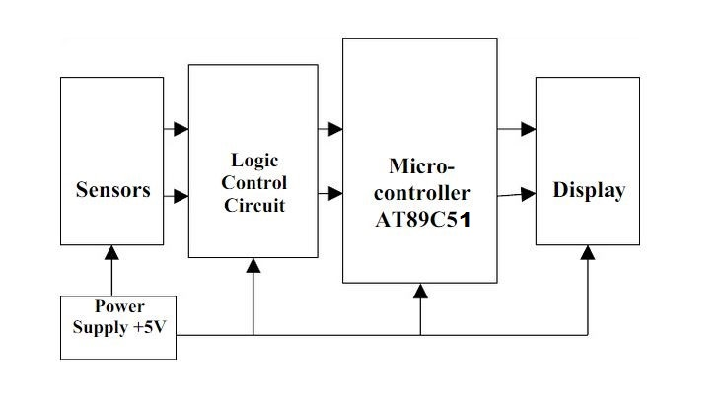

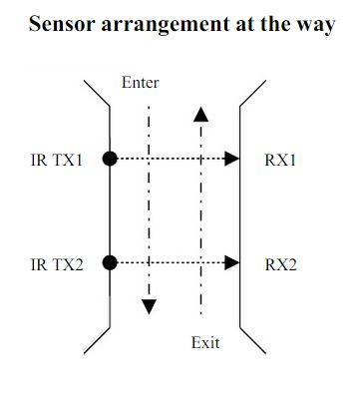

**3. Review of Literature**

**I. Sensors**

The block shows the sensor arrangement at the entrance cum exit passage. Here a pair of IR transmitter – receiver is used as sensor. Photo transistors are used as IR receiver, since it has sensitivity to receive IR rays.

**IR Transmitter:**

**Infrared (IR)** radiation is electromagnetic radiation of a wavelength longer than that of visible light, but shorter than that of microwaves. The name means "below red" (from the Latin infra, "below"), red being the color of visible light with the longest wavelength. Infrared radiation has wavelengths between about 750nm and 1mm, spanning five orders of magnitude. A longer wavelength means it has a lower frequency than red, hence "below". Objects generally emit infrared radiation across a spectrum of wavelengths, but only a specific region of the spectrum is of interest because sensors are usually designed only to collect radiation within a specific bandwidth. Remote controls and IrDA devices use infrared light-emitting diodes (LEDs) to emit infrared radiation which is focused by a plastic lens into a narrow beam. The receiver uses a silicon photo diode to convert the infrared radiation to an electric current. It responds only to the rapidly pulsing signal created by the transmitter, and filters out slowly changing infrared radiation from ambient light. IR does not penetrate walls and so does not interfere with other devices in adjoining rooms.

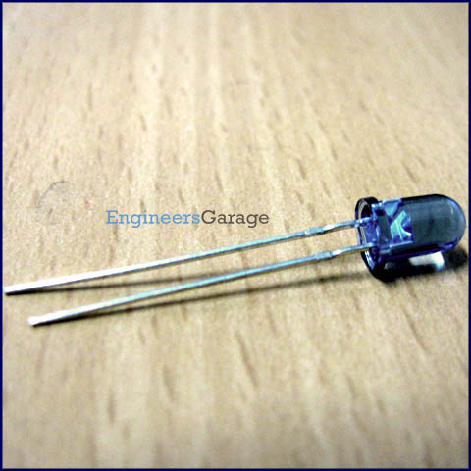

**Fig: Infrared LED**

**II. Logic control circuit**

Here the logic control circuit consists of two circuits, an op-amp comparator and a flip-flop circuit.

**Comparators:** A **comparator** is a device which compares two [voltages](http://en.wikipedia.org/wiki/Voltage) or [currents](http://en.wikipedia.org/wiki/Current_(electricity)) and switches its output to indicate which is larger. A standard [op-amp](http://en.wikipedia.org/wiki/Operational_amplifier) operating without negative feedback is used as a comparator. When the non-inverting input (V+) is at a higher voltage than the inverting input (V-), the high gain of the op-amp causes it to output the most positive voltage it can. When the non-inverting input (V+) drops below the inverting input (V-), the op-amp outputs the most negative voltage it can. Since the output voltage is limited by the supply voltage. Here the operational amplifier LM 324 is used as comparator.

**Pin Diagram of LM324:**

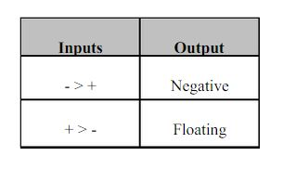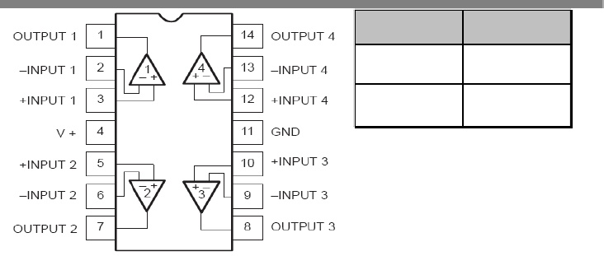

**General description on LM324:**

The LM324 consists of four independent, high-gain, internally frequency-compensated operational amplifiers designed specially to operate from a single power supply over a wide range of voltages. In linear mode, the input common-mode voltage range includes ground and the output voltage can also swing to ground, even though operated from only a single power supply voltage. The unity gain crossover frequency and the input bias current are temperature-compensated.

**Features:**

•Internally frequency-compensated for unity gain

•Large DC voltage gain: 100 dB

•Wide bandwidth (unity gain): 1 MHz (temperature-compensated)

•Wide power supply range Single supply: 3V DC to 30V DC or dual supplies: +/-1.5VDCto +/-15VDC.

•Very low supply current drain: essentially independent of supply voltage (1mW/op amp at +5VDC**)**

•Low input offset voltage: 2 mV DC and offset current: 5nADC

•Differential input voltage range equal to the power supply voltage

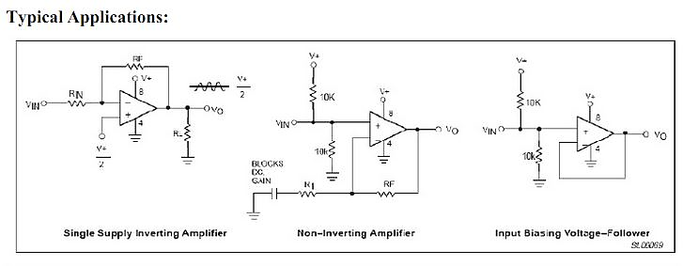•Large output voltage: 0VDCto VCC– 1.5 V DC swing.

**III. Microcontroller AT89C51**

 The AT89C51 is a low-power, high-performance CMOS 8-bit microcomputer with 4Kbytes of Flash programmable and erasable read only memory (PEROM). The device is manufactured using Atmel’s high-density nonvolatile memory technology and is compatible with the industry-standard 80C51 and 80C52 instruction set and pin out. The on-chip Flash allows the program memory to be reprogrammed in-system or by a conventional nonvolatile memory programmer. By combining a versatile 8-bit CPU with Flash on a monolithic chip, the Atmel AT89C51 is a powerful microcomputer which provides a highly-flexible and cost-effective solution to many embedded control applications.

**Features:**

• Compatible with MCS-51™ Products

• 4K Bytes of In-System Reprogrammable Flash Memory

• Endurance: 1,000 Write/Erase Cycles

• Fully Static Operation: 0 Hz to 24 MHz

• Three-level Program Memory Lock

• 128 x 8-bit Internal RAM

• 32 Programmable I/O Lines

• Two 16-bit Timer/Counters

• Six Interrupt Sources

• Programmable Serial Channel

• Low-power Idle and Power-down Modes

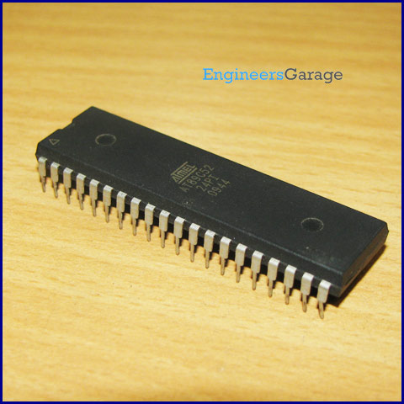

**Pin configuration of Microcontroller AT89C51:**

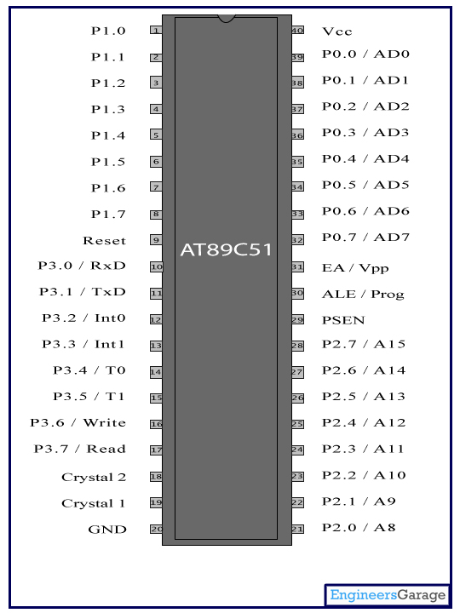

**Pin Description:**

|  |  |  |  |  |  |
| --- | --- | --- | --- | --- | --- |
| Pin No | Function | | | | Name |
| 1 | External count input to Timer/Counter 2, clock-out | | | T2 | P1.0 |
| 2 | Timer/Counter 2 capture/reload trigger and direction control | | | T2 EX | P1.1 |
| 3 | 8 bit input/output port (P1) pins | | | | P1.2 |
| 4 | P1.3 |
| 5 | P1.4 |
| 6 | P1.5 |
| 7 | P1.6 |
| 8 | P1.7 |
| 9 | Reset pin; Active high | | | | Reset |
| 10 | Input (receiver) for serial communication | RxD | 8 bit input/output port (P3) pins | | P3.0 |
| 11 | Output (transmitter) for serial communication | TxD | P3.1 |
| 12 | External interrupt 1 | Int0 | P3.2 |
| 13 | External interrupt 2 | Int1 | P3.3 |
| 14 | Timer1 external input | T0 | P3.4 |
| 15 | Timer2 external input | T1 | P3.5 |
| 16 | Write to external data memory | Write | P3.6 |
| 17 | Read from external data memory | Read | P3.7 |
| 18 | Quartz crystal oscillator (up to 24 MHz) | | | | Crystal 2 |
| 19 | Crystal 1 |
| 20 | Ground (0V) | | | | Ground |
| 21 | 8 bit input/output port (P2) pins  /  High-order address bits when interfacing with external memory | | | | P2.0/ A8 |
| 22 | P2.1/ A9 |
| 23 | P2.2/ A10 |
| 24 | P2.3/ A11 |
| 25 | P2.4/ A12 |
| 26 | P2.5/ A13 |
| 27 | P2.6/ A14 |
| 28 | P2.7/ A15 |
| 29 | Program store enable; Read from external program memory | | | | PSEN |
| 30 | Address Latch Enable | | | | ALE |
| Program pulse input during Flash programming | | | | Prog |
| 31 | External Access Enable;  Vcc for internal program executions | | | | EA |
| Programming enable voltage; 12V (during Flash programming) | | | | Vpp |
| 32 | 8 bit input/output port (P0) pins    Low-order address bits when interfacing with external memory | | | | P0.7/ AD7 |
| 33 | P0.6/ AD6 |
| 34 | P0.5/ AD5 |
| 35 | P0.4/ AD4 |
| 36 | P0.3/ AD3 |
| 37 | P0.2/ AD2 |
| 38 | P0.1/ AD1 |
| 39 | P0.0/ AD0 |
| 40 | Supply voltage; 5V (up to 6.6V) | | | | Vcc |

**Block Diagram of Atmel 89C51 Microcontroller:**

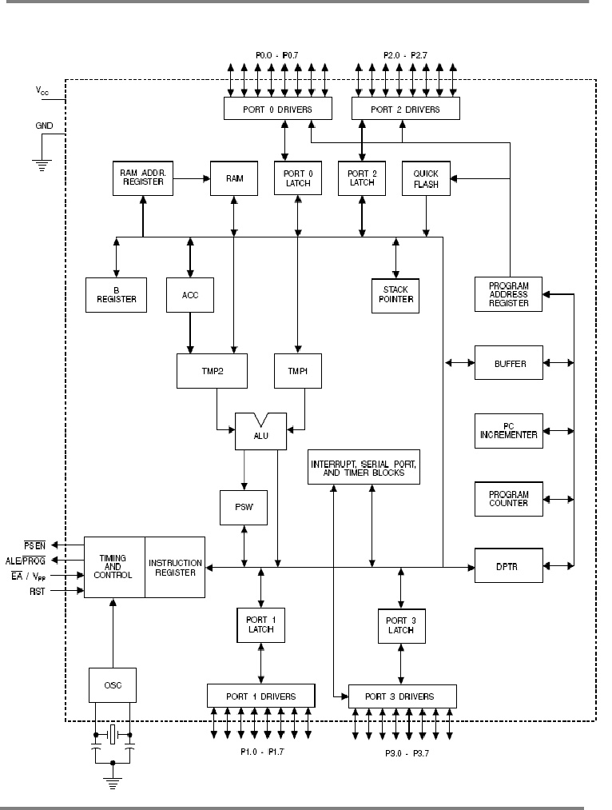

**IV. Display**

The display section comprise of a 16x2 LCD for displaying the number of visitors present.

LCD (Liquid Crystal Display) screen is an electronic display module and find a wide range of applications. A 16x2 LCD display is very basic module and is very commonly used in various devices and circuits. These modules are preferred over [seven segments](http://www.engineersgarage.com/content/seven-segment-display) and other multi segment [LED](http://www.engineersgarage.com/content/led)s. The reasons being: LCDs are economical; easily programmable; have no limitation of displaying special & even [custom characters](http://www.engineersgarage.com/microcontroller/8051projects/create-custom-characters-LCD-AT89C51) (unlike in seven segments), [animations](http://www.engineersgarage.com/microcontroller/8051projects/display-custom-animations-LCD-AT89C51) and so on.

A **16x2 LCD** means it can display 16 characters per line and there are 2 such lines. In this LCD each character is displayed in 5x7 pixel matrix. This LCD has two registers, namely, Command and Data.

The command register stores the command instructions given to the LCD. A command is an instruction given to LCD to do a predefined task like initializing it, clearing its screen, setting the cursor position, controlling display etc. The data register stores the data to be displayed on the LCD. The data is the ASCII value of the character to be displayed on the LCD. Click to learn more about internal structure of a [LCD](http://www.engineersgarage.com/insight/how-lcd-works).

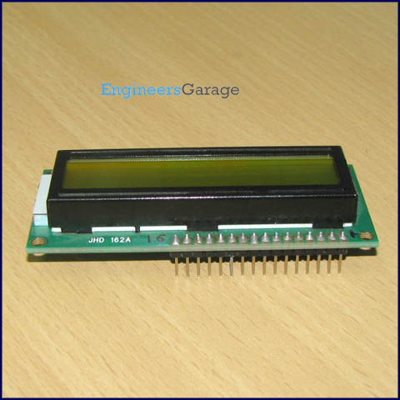

**Pin Diagram:**

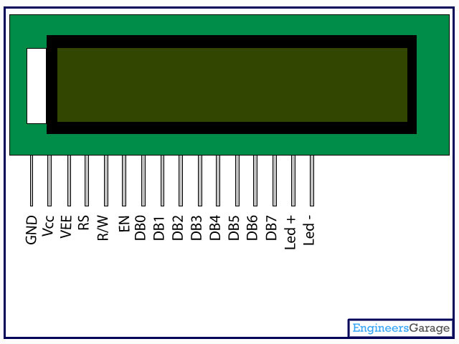

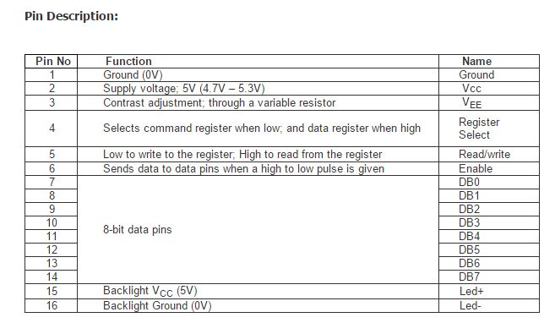

**4. Implementation Details**

**Schematic Diagram of Bidirectional Visitor Counter**

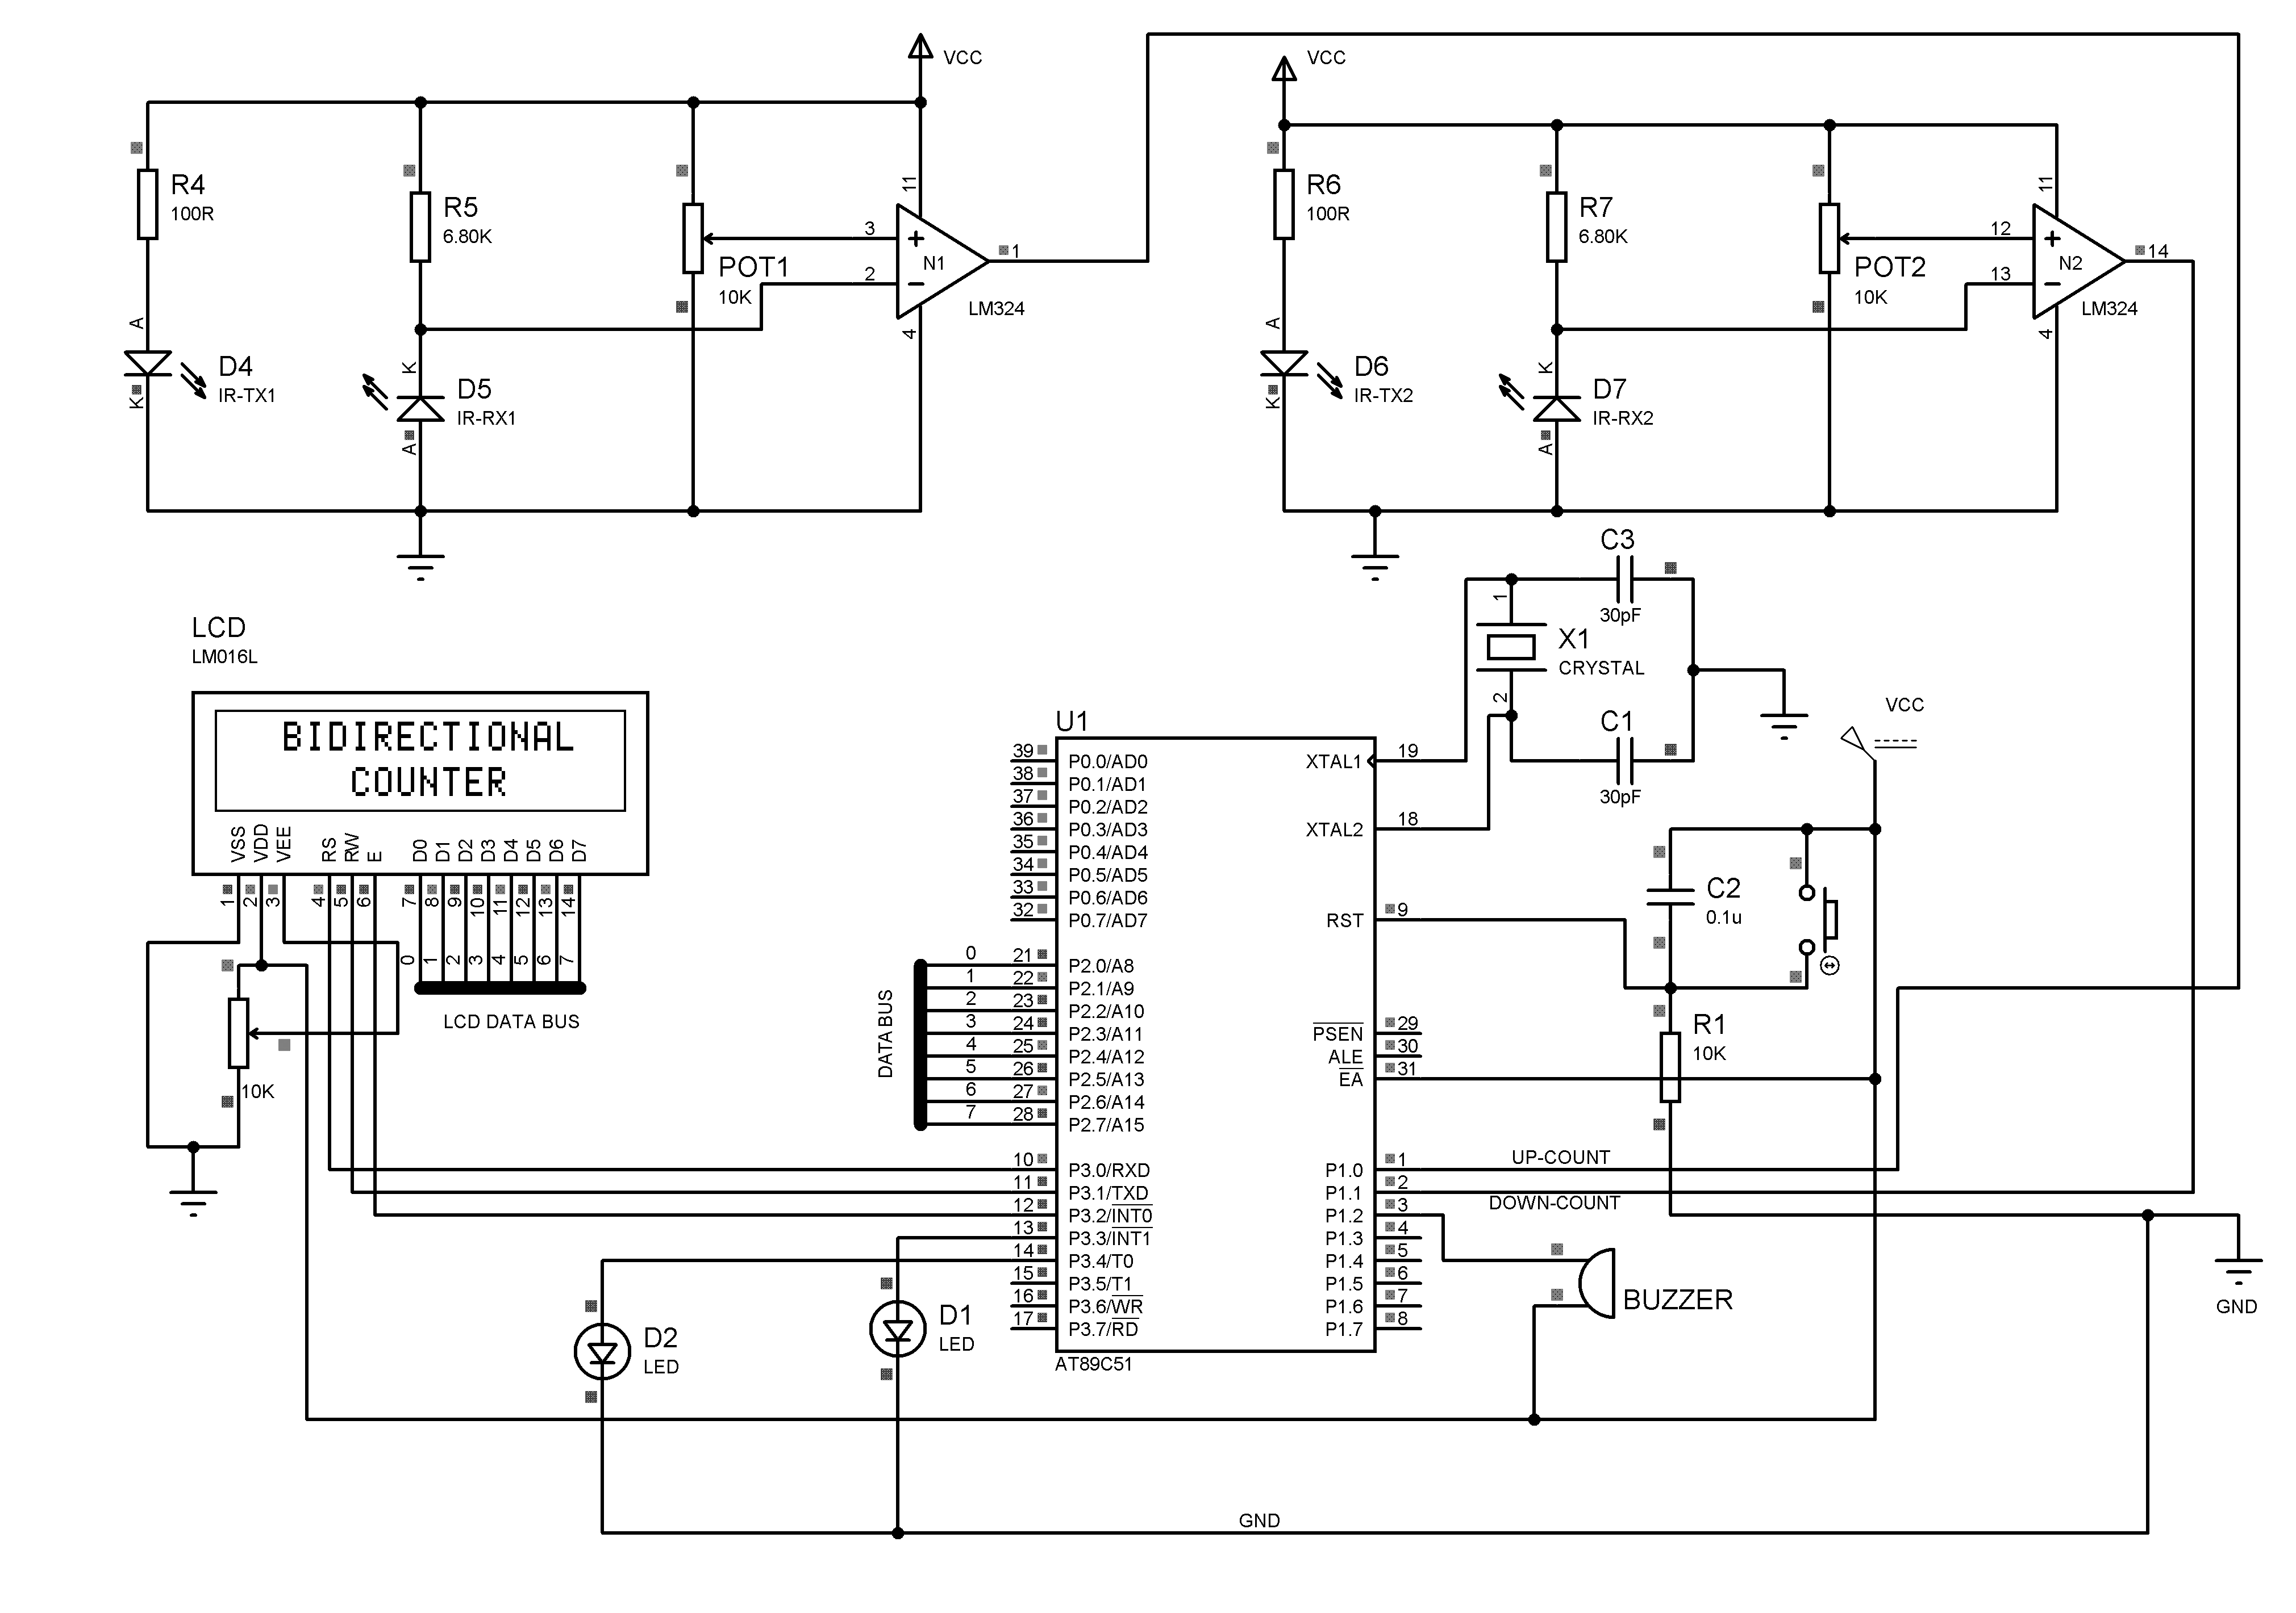

**Circuit Operation**

The circuit shows the microcontroller based bidirectional visitor counter, wherein the transmitter and the receiver form the IR detection circuit. Control logic is built around operational amplifier LM324. The IR transmitter-receiver setup at the entrance-cum-exit of the passage is shown at the block diagram. Two similar sections detect interruption of the IR beam and generate clock pulse for the microcontroller. The microcontroller controls counting and displays the number of persons present inside the hall. When nobody is passing through the entry/exit point, the IR beam continuously falls on IR receiver D5 and D7. IR Rx1 conducts and the voltage at the pin 2 of Op-amp N1 goes low. The voltage at the pin 2 is adjusted by a potentiometer so that it is higher than the low voltage at pin 3. Hence the output of the Op-amp i.e. voltage at pin 1 of N1 is high. Now if someone enters the place, first the IR beam from IR TX1 is interrupted and then the IR beam from IR TX2 is interrupted. When the IR beam from IR TX1 is interrupted the voltage at the pin 2 of Op-amp N1 goes high, while the voltage at pin 3 of N1 is lower than that at pin 2, so the output of N1 goes low. Similarly when IR beam of TX2 is interrupted Output of N2 becomes low. The output of the Op-amps are fed to pin P1.0 and P1.1 of the 8-bit microcontroller AT89C51. The AT89C51 us an 8-bit microcontroller with 4 KB of flash based program memory,128 bytes of RAM, 32 input/output lines, two 16 bits timers/counters, on-chip oscillator and clock circuitry. A 12MHz crystal is used for providing clock. Port 2 is configured for LCD display. Port-0 is an 8-bit, open-drain, bidirectional, input/output (I/O) port. Port-1 and port-2 are 8-bit bidirectional I/O ports with internal pull-ups (no need of external pull-ups).

The microcontroller is programmed in such a way that when it will sense low signal at P1.0 it will increment the count by 1 and when it will sense a low signal at P1.1 it will decrement the count by 1. Now when someone enters the place due to interruption of TX1 low signal is sensed at P1.0 of microcontroller, it increases the count by 1 and then there is a delay of 100ms during which the microcontroller wont sense any signal at P1.0 and P1.1 thus the person can cross the IR beam of TX2 without the microcontroller noticing it, and hence the count wont decrease. Similarly when a person exits it first interrupts the IR beam of IR TX2 and thus low signal is sensed at P1.1,it decreases the count by 1 and goes into a delay subroutine of 100ms during which the person can safely cross the IR beam of TX1 without the microcontroller sensing it i.e. the count won’t increase. In this way a separation is maintained between successive sensing at P1.0 and P1.1.

The count is displayed on a 16x2 LCD through the data sent through port 2 which is configured as an output port.

**5. Algorithm**

**Algorithm:**

**Step 1:** Start the process

**Step 2:** Select port 2 as output port for displaying the count value in LCD.

**Step 3:** When a low signal is sensed at P1.0, increment the count by 1.

**Step 4:** When a low signal is sensed at P1.1, decrement the count by 1.

**Step 5:** Continue the process, whenever a low pulse is sensed at pin P1.0 and pin P1.1.

**Flowchart**

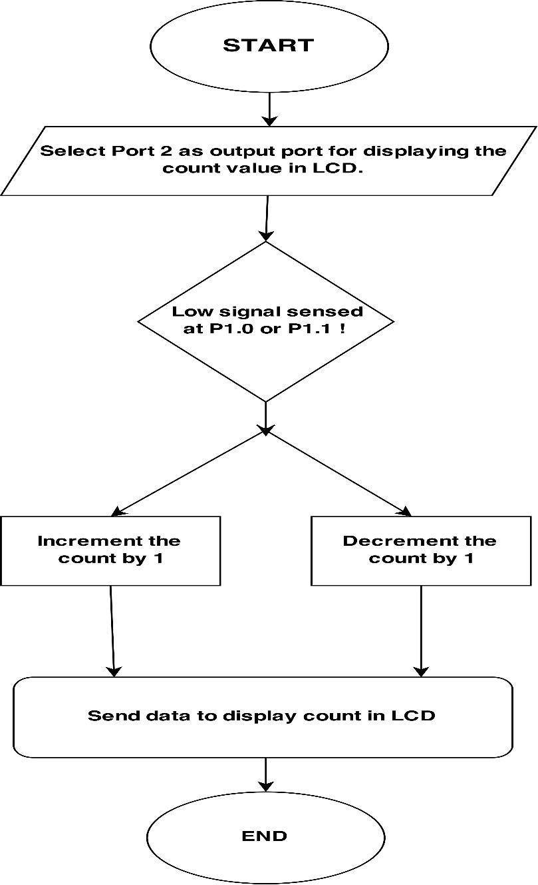

**6. Output**

|  |  |
| --- | --- |
| **WHEN THE IR BEAM IS NOT INTERRUPTED** | |
| Voltage across IR Transmitter | 1.32 volts |
| Voltage across IR Receiver | 0.07 volts |
| Voltage at the non-inverting terminal of Op-amp(Fixed reference voltage) | 0.1 volts |
| Voltage at the inverting terminal of Op-amp(i.e. Voltage across IR Receiver) | 0.07 volts |
| Output voltage of Op-amp | 4.24 volts(Logic 1) |

|  |  |
| --- | --- |
| **WHEN THE IR BEAM IS INTERRUPTED** | |
| Voltage across IR Transmitter | 1.32 volts |
| Voltage across IR Receiver | 1.82 volts |
| Voltage at the non-inverting terminal of Op-amp(Fixed reference voltage) | 0.1 volts |
| Voltage at the inverting terminal of Op-amp(i.e. Voltage across IR Receiver) | 1.82 volts |
| Output voltage of Op-amp | 0.01 volts(Logic 0) |

|  |  |
| --- | --- |
| **MICROCONTROLLER** | |
| Logic low | 0.03 volts |
| Logic High | 4.13 volts |

|  |  |
| --- | --- |
| **BUZZER** | |
| Logic low | 0.03 volts |
| Logic High | 5.62 volts |

**7. Applications**

**Uses:**

* Used to count the visitors of an auditorium, hall, offices, mall, sports etc.
* Used as integral part of security system in high confidential areas.
* Used in Parking Lot.
* Used in Elevator to prevent the maximum limit of weight.

**Advantages:**

* High precision and accuracy can be achieved through it.
* Since it is bidirectional it can count in both directions peoples entering and exiting the place.
* Since it is compact it can be easily implemented anywhere.
* It is also cost effective.

**9. Conclusion**

Thus the project entitled “Bidirectional Visitor Counter” helps to measure the visitor entering and exiting a particular passage or way. The circuit counts both entering and exiting visitors and displays the number of visitors present inside the hall. Visitor counting is not limited to the entry/exit point of a company but has a wide range of applications that provide information to management on the volume and flow of people throughout a location. The visitor helps to maximize the efficiency and effectiveness of employees, floor area and sales potential of an organization. The circuit may also be enhanced with a wide counting range of above three digits by modifying software section of the system. It can also be enhanced for long and accurate sensing range using a laser torch instead of IR transmission circuit. Thus the circuit can be used to monitor visitor flow in effective manner, where the visitors have to counted and controlled.

**10. Bibliography**

* The 8051 Microcontroller and Embedded Systems – Mazidi
* Engineers Garage

<http://www.engineersgarage.com/>

* Op amps and linear integrated circuits by Ramakant A Gayakwad
* Morris Mano -Digital and Computer Logic Design
* Electronic Devices & Circuit Theory Boylestad, Nashelsky
* Wikipedia

www.wikipedia.org